Assessment type (þ):
☐ Questioning (Oral/Written)
☐ Practical Demonstration
☐ 3rd Party Report
☒ Other – Lab 1

Assessment Resources:
The base requirements this assessment task include:
- IDE or editor for developing Python programs (only IDLE and PyCharm supported by the college)
- Access to Office 365 & Microsoft Word
- Virtual machine
You may not need all these for every part in this assessment

Assessment Due:
This assessment is due after the weekly session, Week 1, Friday 17:00.

Assessment Instructions:
- Your code must be written in IDLE or PyCharm IDEs. If you are using a different IDEs or a different structure for your application, then assistance from your lecturers may be limited (at best).
Discuss with your lecturer before straying too far off the path!
- All resources used should be referenced with the question. Answers may not be copied and pasted from any resource. All answers must be reworded to display your understanding.
- You may only use Python functionality, methods and libraries which were taught in this unit.
- First line of code in a program should have the student’s name and number, as proof of authenticity.
- Screenshots of all programs must be included in this document, with the appropriate question.
- Screenshots of testing, showing your code works as intended, should be included with the relevant question.
- Python programs should be named: XXX_Lab##_SYY_QZZ
Replace XXX with your initials
Replace ## with Lab number
Replace YY with Section number,
Replace ZZ with Question number
- It is a submission requirement that all screen shots be signed in some way. Some acceptable examples of signed screen shots are shown below.
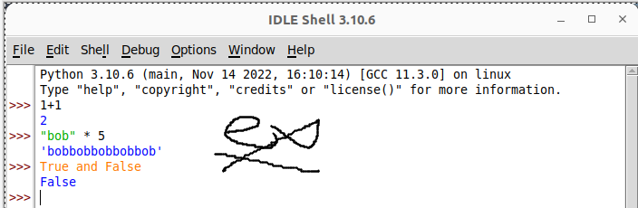
Example 1: Signed using a simple drawing tool.
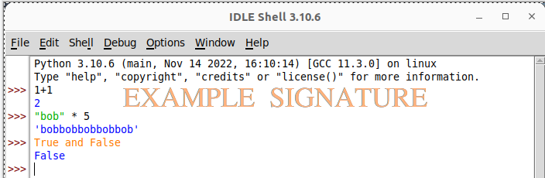
Example 2: Water marked signature.
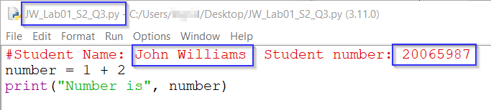
Example 3: Program named as prescribed, as well as first line comment with student name and number.
Program saved as pre-described.
- All python programs must be included in the submission, as well as this document.

Assessment Instrument:

Section 1: Data flow in a computer
In this section, you will need to define how data flows through a system. Use the class lesson power points, online help or any other source to help answer the following questions.
- What is a CPU used for?
The Central Processing Unit, or CPU, is in charge of carrying out the computations and instructions that enable the computer to do tasks.
- What is the main memory (RAM) used for in a computer?
The main purpose of RAM (Random Access Memory) is to temporarily store information and commands that the computer is now using.

Section 2: Algorithms
Again, use online help or simple thought experiments to find the answers to the following questions and problems.
- What is an algorithm?
A collection of instructions created to complete a task is called an algorithm.
- Describe at least two algorithm key components, use the example as a guide
Key component |  |  | Description
Unambiguous (example) |  |  | The algorithm must be clear and exact, computers do not understand “guesses”, “intuition” or other “feelings”.
Input |  |  | Data that has been provided
Processing |  |  | Operation that is carried out on the data
- Develop your own algorithm that solves the following problem (write your answers in clear English using a step-by-step solution, refer to the example in Appendix A for a syntax example):
Problem |  | Calculating the distance in kilometres from a user input of a distance in miles (one mile is equal to 1.609 kilometres)
Algorithm |  | - Request user input & store in a variable  - multiply the stored value with 1.609  - return the product as output
- Identify where your algorithm may fail and add a step to correct it
Possible problem with algorithm |  | User may input a letter instead of a number
New Algorithm |  | - Request user input & store in a variable  - check the users input to make sure it is a number  - if user input is a number multiply the stored value with 1.609 & return the result as output  - else return “Please insert a number”
- Develop another algorithm to solve a simple problem. Your new algorithm must meet the following requirements:
  - Uses a clear structure.
  - Repeats a task.
  - Makes decisions
Problem: | A computer program (a video game) is required to simulate a dice roll to give points to players. The first player to reach 50 points wins.  It must roll the dice (pick a number randomly between 1 and 6) and provide the points to player 1, then do the same for player 2.  Each player starts at 0 points and if the dice rolls a 6, the player it rolled 6 for gets another bonus roll!
Algorithm: | Role the dice  Provide it to player 1  (if point more than 6)  if point is below 6  Provide it to player 2  Check point  If a player gets 50 then he won

Section 3: Scripting languages
Record here using any source you like, the answers to the following questions:
- What is assembly code?
The machine code instructions on a computer are directly translated into assembly code, a low-level programming language.
- What are some of the key components of a scripting language?
Rather than being compiled, scripting languages are usually interpreted.
More flexibility during execution is made possible by dynamic typing, which types variables at runtime.
- How does a scripting language differ from a fully-fledged programming language?
Theoretically, the two differ in that scripting languages are interpreted rather than requiring the compilation stage.
- Why are scripting languages considered “fast to learn and easy to work with?”
Because scripting languages frequently have fewer grammar constraints and conventions and may offer a higher-level abstraction of programming, which makes it easier to do routine tasks with less code, scripting is generally easier to learn than programming.
- Is Python an object orientated or functional language?
Python is a multi-paradigm programming language, which means that it may be used with both functional and object-oriented programming forms.
- What is a programming IDE?
Writing, testing, and debugging code is made easier with an Integrated Development Environment (IDE), a software program that offers a full suite of tools for software development.
- Identify at and describe at least three of the most common Python development environments, ensure you provide a link to the web site for these environments
Environment 1 | PyCharm: The only Python IDE you need  JetBrains created this feature-rich Integrated Development Environment (IDE). Intelligent code completion, error highlighting, debugging tools, integrated version control, and compatibility for multiple web development frameworks are just a few of its potent features.
Environment 2 | Visual Studio Code - Code Editing. Redefined  With the help of extensions, Microsoft's widely used and extremely configurable code editor Visual Studio Code may be transformed into a complete integrated development environment (IDE) for Python.
Environment 3 | Sublime Text - Text Editing, Done Right  A text editor that is quick, very customisable, has a big community, and has a lot of Python packages.

Section 4: Install Python IDLE
You will now be required to install a version of IDLE that will work for your machine. You do not need to re-install Python if it already installed on your lab machine.
- For Windows and MAC Go to https://www.python.org/downloads/ and download the latest version for your operating system
- In Kali or any other Debian family OS use apt install idle3
- In Enterprise Linux family operating systems use dnf install python-tools
Paste a signed screen shot here demonstrating IDLE running on your machine
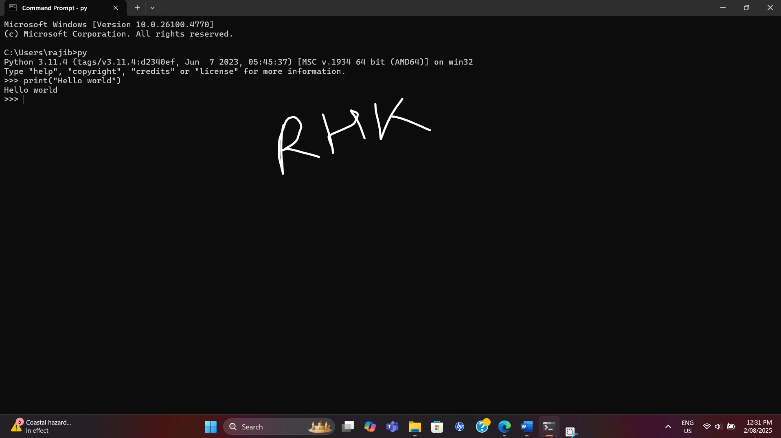

Section 5: Some practice in the interpreter
Conduct the following code executions in the interpreter you have installed, ensure you take screen shot evidence of each. Remember, you must submit the code and the screen shots of the code working as intended!
Question |  | Code and output
- print(“hi my name is Python code”) | 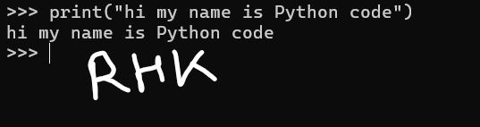
- print(5+1-2*3) | 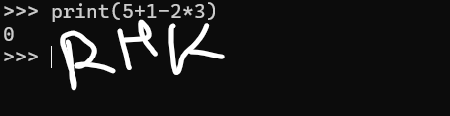
- text = input(“Enter some text”)  print(text) | 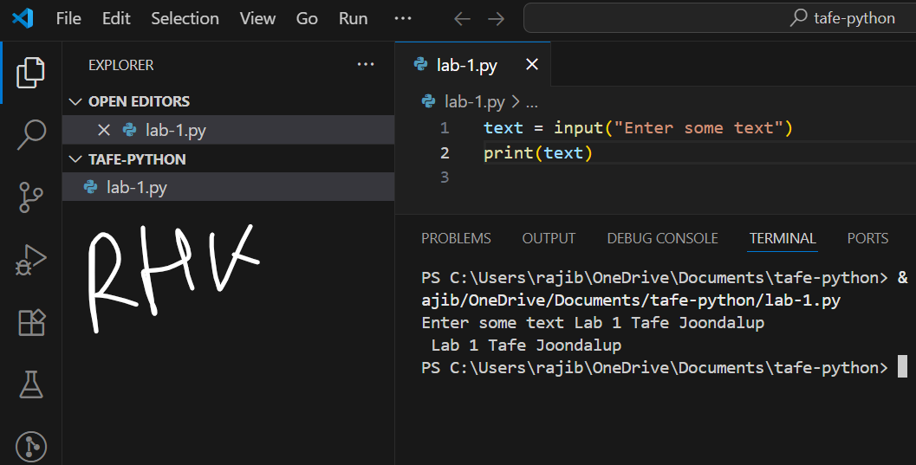
- Kasplode
- word = input(“What is your favourite word? “)  print(len(word)) | 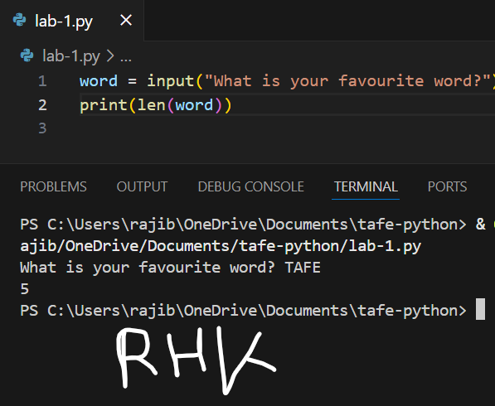
- while True:  print(“All work and no play makes Fox a dull boy”)  *Note, you will have to stop the last command as it will result in an infinite loop. Use the break command (control + C) | 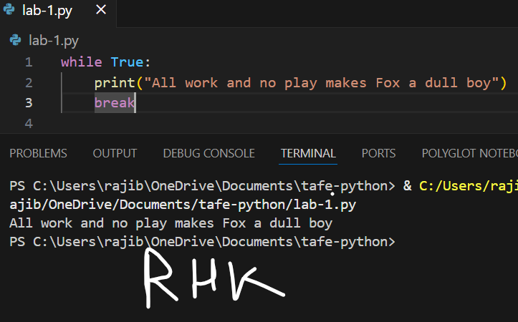

Section 6: Practice creating Python scripts
Throughout this course you will need to write Python code directly into scripts that can be saved and run. This section of the lab will ask you to demonstrate how you can create Python scripts. Make sure you follow all the instructions and take screen shots evidence of you completing your work.

Steps to perform
- In Python IDLE click File > New File.
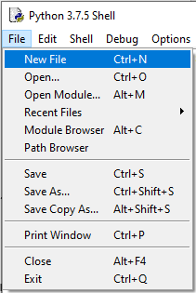

- Write your new Python code like the screen shot provided. To be marked as satisfactory for this lab (and all future labs), you must submit all the Python code scripts you write. All Python scripts you submit for this class must have:
  - Your name.
  - Your student ID.
  - A version number of some kind (the date is a good system for this).
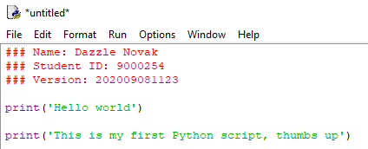

- Press Run or use F5 to run your script. Python will require you to save your script first, ensure you save the script as specified before (example, “XXX_Lab1_S6_Q1py”). Provide a screen shot of your code running as expected in the Python console.

Screenshot of Program and output:

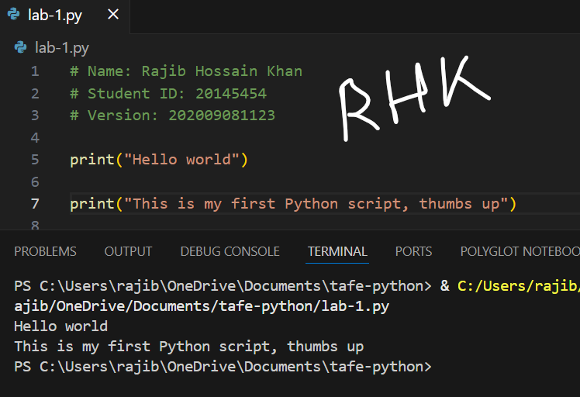

Appendix A: Sample get out of bed and go to work algorithm
Here is a sample algorithm for getting out of bed and going to work.
- Set an alarm: Determine the time you need to wake up and set an alarm clock or use a smartphone alarm to wake you up at that time.
- Wake up and stretch: When the alarm goes off, turn it off and take a moment to stretch your body to help wake up and increase blood flow.
- Get out of bed: Leave your bed and stand up. Avoid hitting the snooze button and resist the temptation to stay in bed longer.
- Freshen up: Go to the bathroom, brush your teeth, wash your face, and get ready for the day. This will help you feel refreshed and prepared for work.
- Get dressed: Put on your work attire or the appropriate clothing for the day. This step may involve selecting an outfit and ensuring it is clean and presentable.
- Have breakfast: Prepare and eat a nutritious breakfast to fuel your body for the day ahead. This can include options like cereal, toast, yogurt, or fruit.
- Gather essentials: Collect any necessary items you need for work, such as your laptop, work bag, keys, and any documents or materials you'll need for the day.
- Leave for work: Double-check that you have everything you need, lock your home if necessary, and head out to your workplace. If you use public transportation or drive, make sure to account for the time needed to commute.
- Arrive at work: Reach your workplace on time and begin your workday.

